Energy in Simple Harmonic Motion
We can describe an oscillating mass in terms of its position, velocity, and acceleration as a function of time. We can also describe the system from an energy perspective. In this experiment, you will measure the position and velocity as a function of time for an oscillating mass and spring system, and from those data, plot the kinetic and potential energies of the system.
Energy is present in three forms for the mass and spring system. The mass m, with velocity v, can have kinetic energy KE
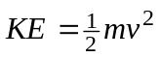
The spring can hold elastic potential energy, or PEelastic. We calculate PEelastic by using
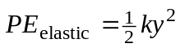
where k is the spring constant and y is the extension or compression of the spring measured from the equilibrium position.
The mass and spring system also has gravitational potential energy (PEgravitational = mgy), but we do not have to include the gravitational potential energy term if we measure the spring length from the hanging equilibrium position. We can then concentrate on the exchange of energy between kinetic energy and elastic potential energy.
If there are no other forces experienced by the system, then the principle of conservation of energy tells us that the sum ΔKE + ΔPEelastic = 0, which we will test experimentally.
objectives
- Examine the energies involved in simple harmonic motion.
- Test the principle of conservation of energy.
Materials
Windows PC | slotted mass set, 50 g to 300 g in 50-g steps
LabPro | slotted mass hanger
Logger Pro | spring, 1-10 N/m
Vernier Motion Detector | ring stand

Preliminary questions
1. Sketch a graph of the height vs. time for the mass on the spring as it oscillates up and down through one cycle. Mark on the graph the times where the mass moves the fastest and therefore has the greatest kinetic energy. Also mark the times when it moves most slowly and has the least kinetic energy.

2. On your sketch, label the times when the spring has its greatest elastic potential energy. Then mark the times when it has the least elastic potential energy.
3. From your graph of height vs. time, sketch velocity vs. time.

4. Sketch graphs of kinetic energy vs. time and elastic potential energy vs. time.
Procedure
1. Mount the 200-g mass and spring as shown in Figure 1. Connect the Motion Detector to DIG/SONIC 2 of the LabPro or PORT 2 of the Universal Lab Interface. Position the Motion Detector directly below the hanging mass, taking care that no extraneous objects could send echoes back to the detector. Protect the Motion Detector by placing a wire basket over the detector. The mass should be about 60 cm above the detector when it is at rest. Using amplitudes of 5 cm or less will then keep the mass outside of the 40 cm minimum distance of the Motion Detector. THE SAMPLE RATE MAY NEED TO BE CHANGED.  2. Open the Experiment 17 folder from Physics with Computers. Then open the experiment file Exp 17a Motion Detector. Two graphs should be displayed on the screen. The top graph is distance vs. time. The lower graph is velocity vs. time.  3. Start the mass moving up and down by pulling it 5 cm and then releasing it. Take care that the mass is not swinging from side to side. Click  to record position and velocity data.  4. Print your graphs and compare to your predictions. Comment on any differences. | 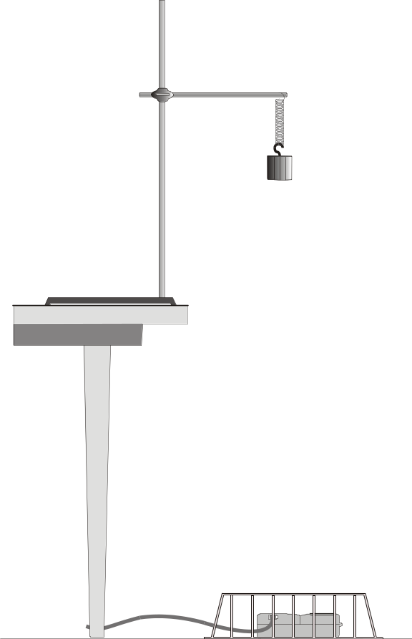  Figure 1
________________________________________________________________________________________________________________________________________________________________________________________________________________________________________________________________________________________________________________________________________
Measuring the Spring Constant
5. To calculate the spring potential energy, it is necessary to measure the spring constant k. Hooke’s law states that the spring force is proportional to its extension from equilibrium, or F = –kx. You can apply a known force to the spring, to be balanced in magnitude by the spring force, by hanging a range of weights from the spring. The Motion Detector can then be used to measure the equilibrium position. Open the experiment file Exp 17b Spring Constant. Logger Pro is now set up to plot the applied weight vs. distance.
6. Click to begin data collection. Hang a 50-g mass from the spring and allow the mass to hang motionless. Click and enter 0.49, the weight of the mass in newtons (N). Press ENTER to complete the entry. Now hang 100, 150, 200, 250, and 300 g from the spring, recording the position and entering the weights in N. When you are done, click  to end data collection.
7. Click on the Regression Line tool, , to fit a straight line to your data. The magnitude of the slope is the spring constant k in N/m. Record the value in the data table below.
8. Remove the 300-g mass and replace it with a 200-g mass for the following experiments.
Conservation of Energy
9. Open the experiment file Exp 17c Energy. In addition to plotting position and velocity, three new data columns have been set up in this experiment file (kinetic energy, elastic potential energy, and the sum of these two individual energies). You may need to modify the calculations for the energies. If necessary, choose Modify Column Kinetic Energy from the Data menu and substitute the mass of your hanging mass in kilograms for the value 0.20 in the definition, then click . Similarly, change the spring constant you determined above for the value 5.0 in the potential energy column.
10. With the mass hanging from the spring and at rest, click  to zero the Motion Detector. From now on, all distances will be measured relative to this position. When the mass moves closer to the detector, the distance reported will be negative.
11. Start the mass oscillating in a vertical direction only, with an amplitude of about 10 cm. Click to gather position, velocity, and energy data.
DATA TABLE
Spring constant | N/m

Analysis
1. Click on the y-axis label of the velocity graph to choose another column for plotting. Uncheck the velocity column and select the kinetic energy and potential energy columns. (You may have to change the zoom.)
2. Compare your two energy plots to the sketches you made earlier. Be sure you compare to a single cycle beginning at the same point in the motion as your predictions. Comment on any differences.
3. If mechanical energy is conserved in this system, how should the sum of the kinetic and potential energies vary with time? Sketch your prediction of this sum as a function of time.

4. Check your prediction. Click on the y-axis label of the energy graph to choose another column for plotting. Select the total energy column in addition to the other energy columns. Click to draw the new plot.
5. From the shape of the total energy vs. time plot, what can you conclude about the conservation of mechanical energy in your mass and spring system?
__________________________________________________________________________________________________________________________________________________________________________________________________________________________________________________________________________________________________________________________________________________________________________________________________________________________
6. Compare the total energy vs. time graph to your prediction sketch of the sum of the two energies. Comment on any similarities or differences.
________________________________________________________________________________________________________________________________________________________________________________________________________________________________________________________________________________________________________________________________________
7. Comment on the validity of your results/conclusion. Offer suggestions to improve the experiment/results.
_______________________________________________________________________________________________________________________________________________________________________________________________________________________________________________________________________________________________________________________________________
Final Prediction: Imagine taping an index card to the bottom of the mass so as to increase its air resistance. Sketch a graph of the sum of Kinetic and Elastic Potential Energies vs. Time.
How would the total energy be affected by the index card?

Energy in Simple Harmonic Motion Rubric
 | 4 – Excellent | 3 – Proficient | 2 – Marginal | 1 - Unsatisfactory | Self-asses | Grade
Preliminary Questions (15) | - All graphs are completed, with necessary marks  - All units and labels are included  - Graphs show a well-thought-out response to the question | - All graphs are completed, with most necessary marks  - Most units and labels are included  - Graphs show a thought-out response to the question | - Graphs are completed  - Few units and labels are included  - Graphs show a limited thought-out response to the question | - One or more graphs are incomplete  - Very few units and labels are included  - Graphs show no thought
Procedure (15) | - It is evident that directions were followed  - All necessary data is obtained in a timely fashion | - Most directions were followed well  - All necessary data is obtained | - Few directions were followed  - Most necessary data is obtained | - Group did not use time efficiently  - Some data is missing
Analysis (15) | - A deep understanding of the experiment and concepts is evident from the graphs and comments  - Conclusions are fully supported by data and address the main concept | - A general understanding of the experiment and concepts is evident from the graphs and comments  - Conclusions are generally supported by data and address the main concept. Minor errors in interpretation of results may be present. | - A limited understanding of the experiment and concepts is evident from the graphs and comments  - Conclusions are somewhat supported by data and address the main concept. Major errors in interpretation of results may be present. | - A very poor understanding of the experiment and concepts is evident from the graphs and comments  - Conclusions are not supported by data, do not address the main concept or are missing.
Validity (5) | - Validity of conclusions are thoroughly discussed  - Well thought out suggestions for improvement are made | - Comment on validity of conclusions is general  - Suggestions for improvement are made | - Comment on validity of conclusions is limited  - No suggestions for improvement are made | - No comment on the validity is made
Final Prediction (5) | - Graph and response shows the ability to synthesize the main concept and produce a well thought out hypothesis | - Graph and response shows the ability to understand the main concept and produce a hypothesis | - Graph and response shows a limited understanding and ability to produce a hypothesis | - Graph and response shows very little understanding of main concept
Total:
Comments:

